BESTÄLLARE: __________________________________
TELEFON: __________________________________
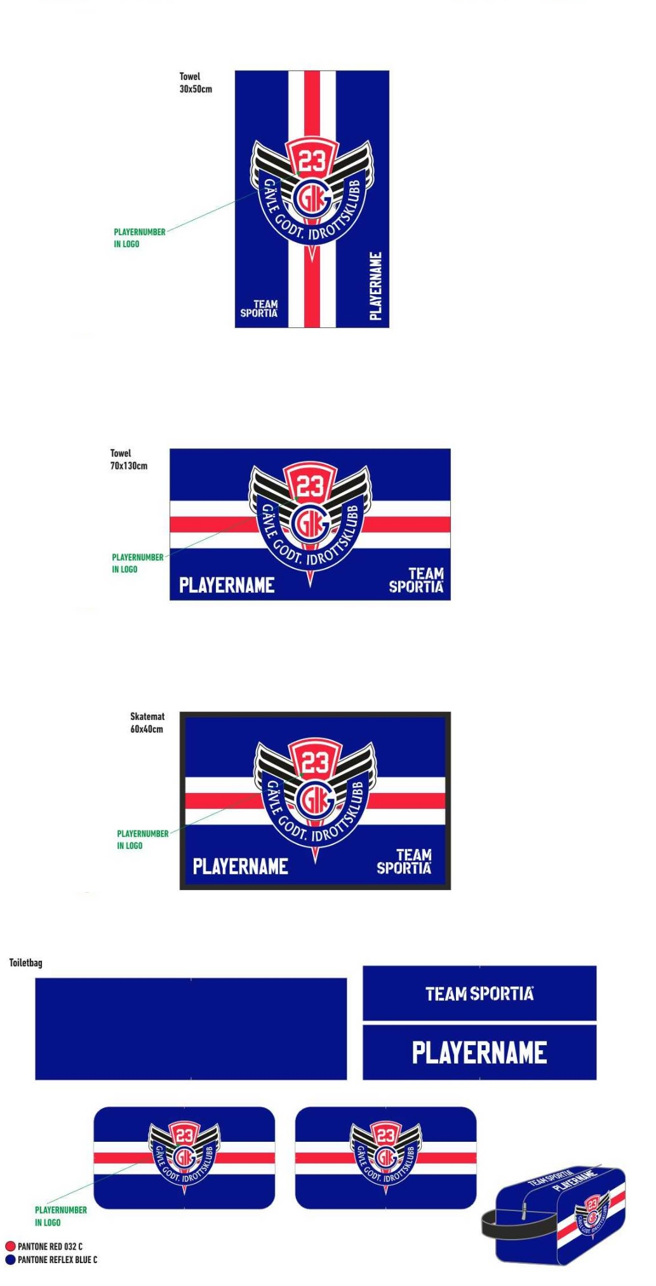
LAGNAMN: __________________________________

1704 HANDDUK 30x50 cm
99 kr

PLAYERNUMBER: ___________

PLAYERNAME: _________________

1664 HANDDUK 70x130 cm
299 kr

PLAYERNUMBER: ___________

PLAYERNAME: _________________

1678 LOCKERROOM MATTA - S 60x40 cm
299 kr

PLAYERNUMBER: ___________

PLAYERNAME: _________________

1717 TOILETRY BAG 15x15x28 cm
279 kr

PLAYERNUMBER: ___________

PLAYERNAME: _________________

